Kabir Kanha Arora
Rakesh Verma
CSD 330 – Security Analytics
18 April 2020

Detection of Cyber Harassers on Social Media: Final Report

Problem Statement

The goal is to classify a message/comment/any written text exchanged between two people as an instance of bullying or not, to detect cyber harassers and to make the internet a safer place. This idea is born out of a pressing need to curb a growing problem. Even the best of things come with their pitfalls. Growing technology and connectivity have led to an increased number of child predators and cyber stalkers online. My solution aims to efficiently nip this problem in the bud using Machine Learning approaches like Naïve Bayes, Support Vector Machines (SVM), Decision Trees, K-Nearest Neighbours, Random Forests and Logistic Regression.

Use Cases

The use cases for this problem are virtually unlimited. Users on almost all social media websites and discussion forums can fall prey to such predators. This tool will be prototyped on a platform and then generalized to suit the requirements of all such platforms, thereby leaving a huge population much safer than they were before. Any website can use this tool to flag suspicious profiles and become a much better space for all its users.

Motivation

Social media has opened doors for people who misuse it to undermine, harass, humiliate. Threaten and bully others. There is a lack of resources to detect and hinder its occurrence. On average, about 16% students have admitted that they have been bullied at some point in their lives, as per surveys conducted in the United States. The problem is hence indeed grave and needs to be addressed.

Dataset

The dataset I have used for this project is the one provided at Kaggle, which was part of a contest held 8 years ago. https://www.kaggle.com/c/detecting-insults-in-social-commentary. There is a separate training data set with roughly 4000 tuples and a testing data set with about 2500 tuples. Each entry contains a date, a comment and a label, where ‘1’ indicates that it is an insult and ‘0’ indicates that it is neutral.

Approach

Now, since we have just one feature that is to be used to predict the label, I start to build a vocabulary, using somewhat a bag of words approach. It is important to note here that this data set is off a website that has casual chats and hence, there are typos galore, The data is pretty dirty and preprocessing and cleaning takes up a major chunk of the effort.

I saw a large number of words with front slashes and backslashes like \xe2, which are probably escape sequences and have a special meaning, so to remove them, as they are garbage to us, I create a regular expression of the form:

slash_all = r'\s*(?:[\w_]*[/\\](?:[\w_]*[/\\])*[\w_]*)'
Which is then followed by:

comment = re.sub(slash_all,' ',comment)
I also remove all special characters except the apostrophe (‘) since none of them are useful to us, trim extra whitespace and change every character to lower case to avoid double counting and to ensure uniformity.

I then tokenize the comments, which essentially means that I break it up into a collection of words and then I remove stop words, which are the very common natural language words, that add little or no meaning to any sentence. After this, stemming is done to get all the words into their root forms to create further uniformity. I also perform lemmatization, which, in hindsight, was sort of useless after stemming, and just one of them should have been chosen. Collectively, these steps work to reduce the size of the vocabulary and prevent it from blowing up.

Once the data is ready to go, I run it through six classifiers – Naïve Bayes, Decision Tree, Support Vector Classifier, Random Forest, Logistic Regression and K-Nearest Neighbours. The results of all three, in order, are shown below.

NAÏVE BAYES

Confusion Matrix
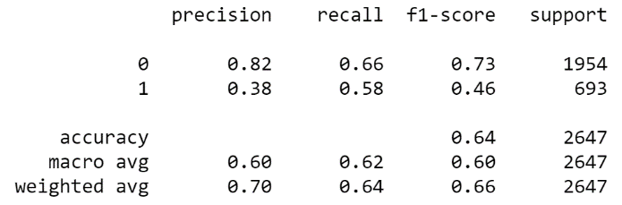
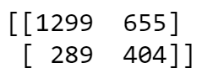

Classification Report

AUC
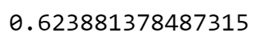
DECISION TREE

Confusion Matrix
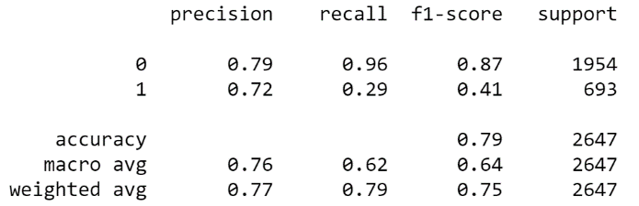
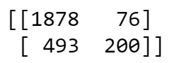

Classification Report

AUC
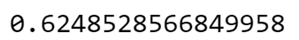

SUPPORT VECTOR CLASSIFIER (SVC)

Confusion Matrix
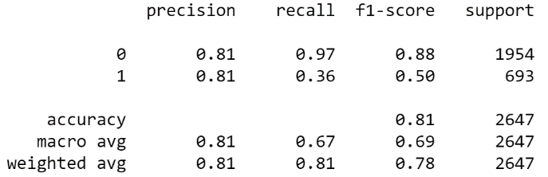
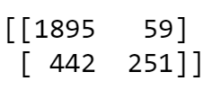

Classification Report

AUC
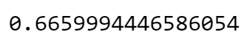

LOGISTIC REGRESSION

Confusion Matrix
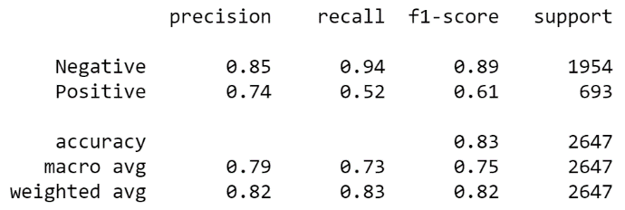
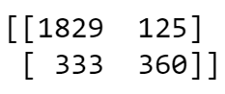

Classification Report

AUC
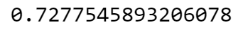

K-NEAREST NEIGHBOURS

Confusion Matrix
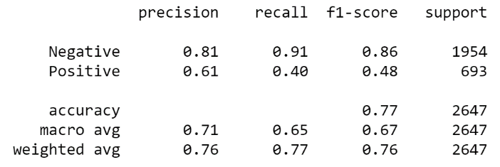
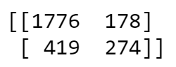

Classification Report

AUC
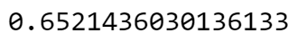

RANDOM FOREST

Confusion Matrix
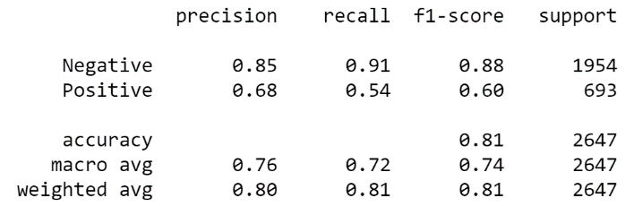
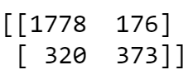

Classification Report

AUC
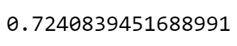

Looking at the results, we see that in terms of Area under Receiver Operator Characteristic Curve and Accuracy, the three classifiers that stand out above the rest are – Support Vector Classifier, Random Forest and Logistic Regression.

So, now we shortlist these three classifiers and try to optimize them using Grid Search for a better performance. Note that since the dataset is imbalanced and we are far more interested in detecting all the cases of bullying, recall is the most important factor for us. We could also look at the f2-score, but since recall is readily available in the classification report, we shall stick to it.

For grid search, the parameters varied, and the outputs are as follows:

SUPPORT VECTOR CLASSIFIER (SVC)

Parameter | Definition | Values
C | Regularisation Parameter. | [0.1,1, 10, 100]
gamma | Kernel Coefficient. | [1,0.1,0.01,0.001]
kernel | Kernel Type | ['rbf', 'poly', 'sigmoid']

Best estimator:
SVC(C=10, break_ties=False, cache_size=200, class_weight=None, coef0=0.0,
decision_function_shape='ovr', degree=3, gamma=0.01, kernel='rbf',
max_iter=-1, probability=False, random_state=None, shrinking=True,
tol=0.001, verbose=False)

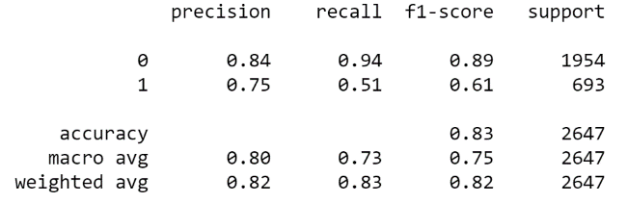
Confusion Matrix
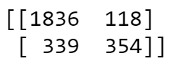

Classification Report

LOGISTIC REGRESSION

Parameter | Definition | Values
C | Inverse of regularization strength | [100,10,1.0,0.1,0.01,0.001]
solver | Algorithm | ['newton-cg', 'lbfgs', 'liblinear','sag','saga']
penalty | Norm used in penalization. | ['none', 'l1', 'l2','elasticnet']

Best estimator:
LogisticRegression(C=1.0, class_weight=None,dual=False,fit_intercept=True,intercept_scaling=1, l1_ratio=None, max_iter=100,multi_class='auto',
n_jobs=None, penalty='l1',random_state=None, solver='liblinear',
tol=0.0001, verbose=0,warm_start=False)

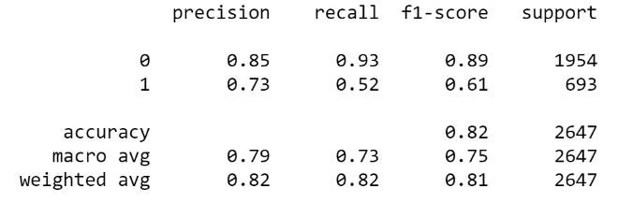
Confusion Matrix
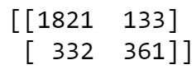

Classification Report

RANDOM FOREST

Parameter | Definition | Values
n-estimators | Number of trees | [10, 100, 1000]
max_features | Number of features | ['sqrt', 'log2']

Best estimator:
RandomForestClassifier(bootstrap=True, ccp_alpha=0.0, class_weight=None,
criterion='gini', max_depth=None, max_features='sqrt',
max_leaf_nodes=None, max_samples=None,
min_impurity_decrease=0.0, min_impurity_split=None,
min_samples_leaf=1, min_samples_split=2,
min_weight_fraction_leaf=0.0, n_estimators=1000,
n_jobs=None, oob_score=False, random_state=None,
verbose=0, warm_start=False)

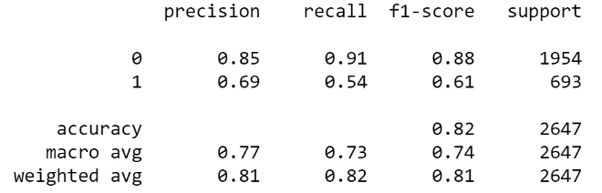
Confusion Matrix
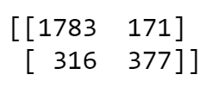

Classification Report

We start to see a good increase in performance, but there’s still a lot of scope for improvement. I tried to run the GridSearch in a modified manner so that instead of looking at all the metrics, it would focus on recall. I tried running the same on the Random Forest classifier, but got exactly the same result so that approach was trashed.

I also tried using XGBoost but the results were not that great without hyperparameter tuning, which I did again using GridSearch on XGBoost. It is worth mentioning that each gridSearch took about two hours and required a whole new level of patience. The results for that were as follows:

Parameter | Values
eta | [0.10, 0.20, 0.30 ]
max_depth | [3, 4, 5]
min_child_weight | [1, 3, 5, 7]
gamma | [0.1, 0.2 , 0.3]
colsample_bytree | [0.3, 0.4, 0.5]

Best estimator:
XGBClassifier(base_score=0.5, booster='gbtree', colsample_bylevel=1,
colsample_bynode=1, colsample_bytree=0.5, eta=0.1, gamma=0.3,
learning_rate=0.1, max_delta_step=0, max_depth=5,
min_child_weight=1, missing=None, n_estimators=100, n_jobs=1,
nthread=None, objective='binary:logistic', random_state=0,
reg_alpha=0, reg_lambda=1, scale_pos_weight=1, seed=None,
silent=None, subsample=1, verbosity=1)
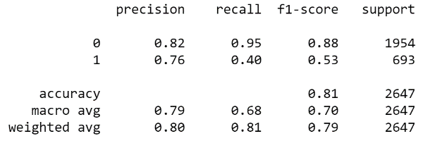
Confusion Matrix
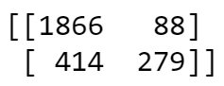

Classification Report

We see that even this approach does not seem to be getting us anywhere, so we abandon it right away. Now, since the dataset is quite imbalanced (1:3), I try to look at a combination of under sampling and oversampling on the training set to improve my classifier. For this purpose, I used SMOTETomek on the training data and then used the best SVC classifier, as obtained earlier by GridSearch. The training data then got resampled into a balanced configuration.

Using this updated training data, I re-ran the optimal classifiers (as returned by GridSearch) and the results are as follows:

LOGISTIC REGRESSION

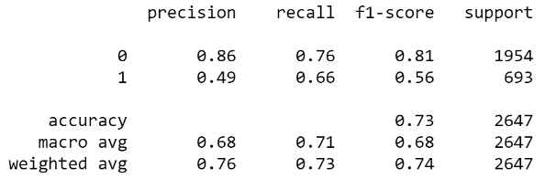
Confusion Matrix
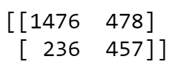

Classification Report

RANDOM FOREST

Confusion Matrix
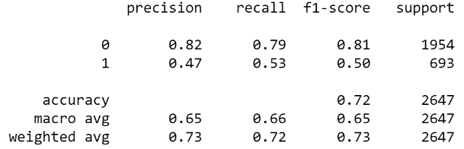
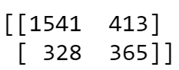

Classification Report

SUPPORT VECTOR CLASSIFIER

Confusion Matrix
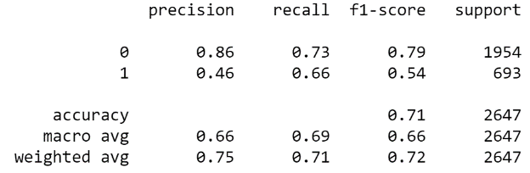
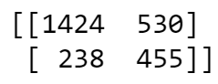

Classification Report

Conclusions
- It is extremely difficult to achieve a higher recall without compromising on the other metrics heavily.
- Logistic Regression and Support Vector classifiers work the best.
- Grid Search can really improve the performance of any algorithm, but it is very slow and hence Random GridSearch could be looked instead.
- It is easy to achieve high accuracy but it doesn’t mean much as long as the data is imbalanced.

Future Scope

- This research can also be expanded to other datasets available on the internet, such as BayzickBullyingData, TextMiningAndCyberCrimeData, Formspring Data.
- The Wikipedia list of bad words could also be added to the vocabulary to enhance the classification.
- We could also include TF-IDF to get a better result.
- A semi-supervised algorithm like Label Propagation or Label Spreading may also be used.
- Majority voting could be used.

References

Research work

Samghabadi, Niloofar Safi, et al. "Detecting nastiness in social media." Proceedings of the First Workshop on Abusive Language Online. 2017.
Escalante, Hugo Jair, et al. "Sexual predator detection in chats with chained classifiers." Proceedings of the 4th Workshop on Computational Approaches to Subjectivity, Sentiment and Social Media Analysis. 2013.
Miah, Md Waliur Rahman, John Yearwood, and Sid Kulkarni. "Detection of child exploiting chats from a mixed chat dataset as a text classification task." Proceedings of the Australasian Language Technology Association Workshop 2011. 2011.
Huang, Qianjia, Vivek Kumar Singh, and Pradeep Kumar Atrey. "Cyber bullying detection using social and textual analysis." Proceedings of the 3rd International Workshop on Socially-Aware Multimedia. 2014.
Nandhini, B. Sri, and J. I. Sheeba. "Online social network bullying detection using intelligence techniques." Procedia Computer Science 45 (2015): 485-492.
Xu, Jun-Ming, et al. "Learning from bullying traces in social media." Proceedings of the 2012 conference of the North American chapter of the association for computational linguistics: Human language technologies. Association for Computational Linguistics, 2012.

Websites

Agarwal, Rahul. "The 5 Sampling Algorithms Every Data Scientist Need To Know". Towardsdatascience, Medium, 21 July 2019, https://towardsdatascience.com/the-5-sampling-algorithms-every-data-scientist-need-to-know-43c7bc11d17c.
Brownlee, Jason. "A Gentle Introduction to XGBoost for Applied Machine Learning". Machinelearningmastery, 17 August 2016, https://machinelearningmastery.com/gentle-introduction-xgboost-applied-machine-learning/.
Starmer, Joshua. “XGBoost Part 2: XGBoost Trees for Classification”. Statquest, Wordpress, 18 February 2020, https://statquest.org/2020/01/18/xgboost-part-2-xgboost-trees-for-classification/.
Dubey, Praveen. “An Introduction to Bag of Words and how to code it in Python for NLP”. Freecodecamp, 18 December 2018, https://www.freecodecamp.org/news/an-introduction-to-bag-of-words-and-how-to-code-it-in-python-for-nlp-282e87a9da04/.
Brownlee, Jason. "Tune Hyperparameters for Classification Machine Learning Algorithms". Machinelearningmastery, 13 December 2019, https://machinelearningmastery.com/hyperparameters-for-classification-machine-learning-algorithms/
Badr, Will. "Having an Imbalanced Dataset? Here is how you can fix it". Towardsdatascience, Medium, 22 Feb 2019, https://towardsdatascience.com/having-an-imbalanced-dataset-here-is-how-you-can-solve-it-1640568947eb.

Appendix

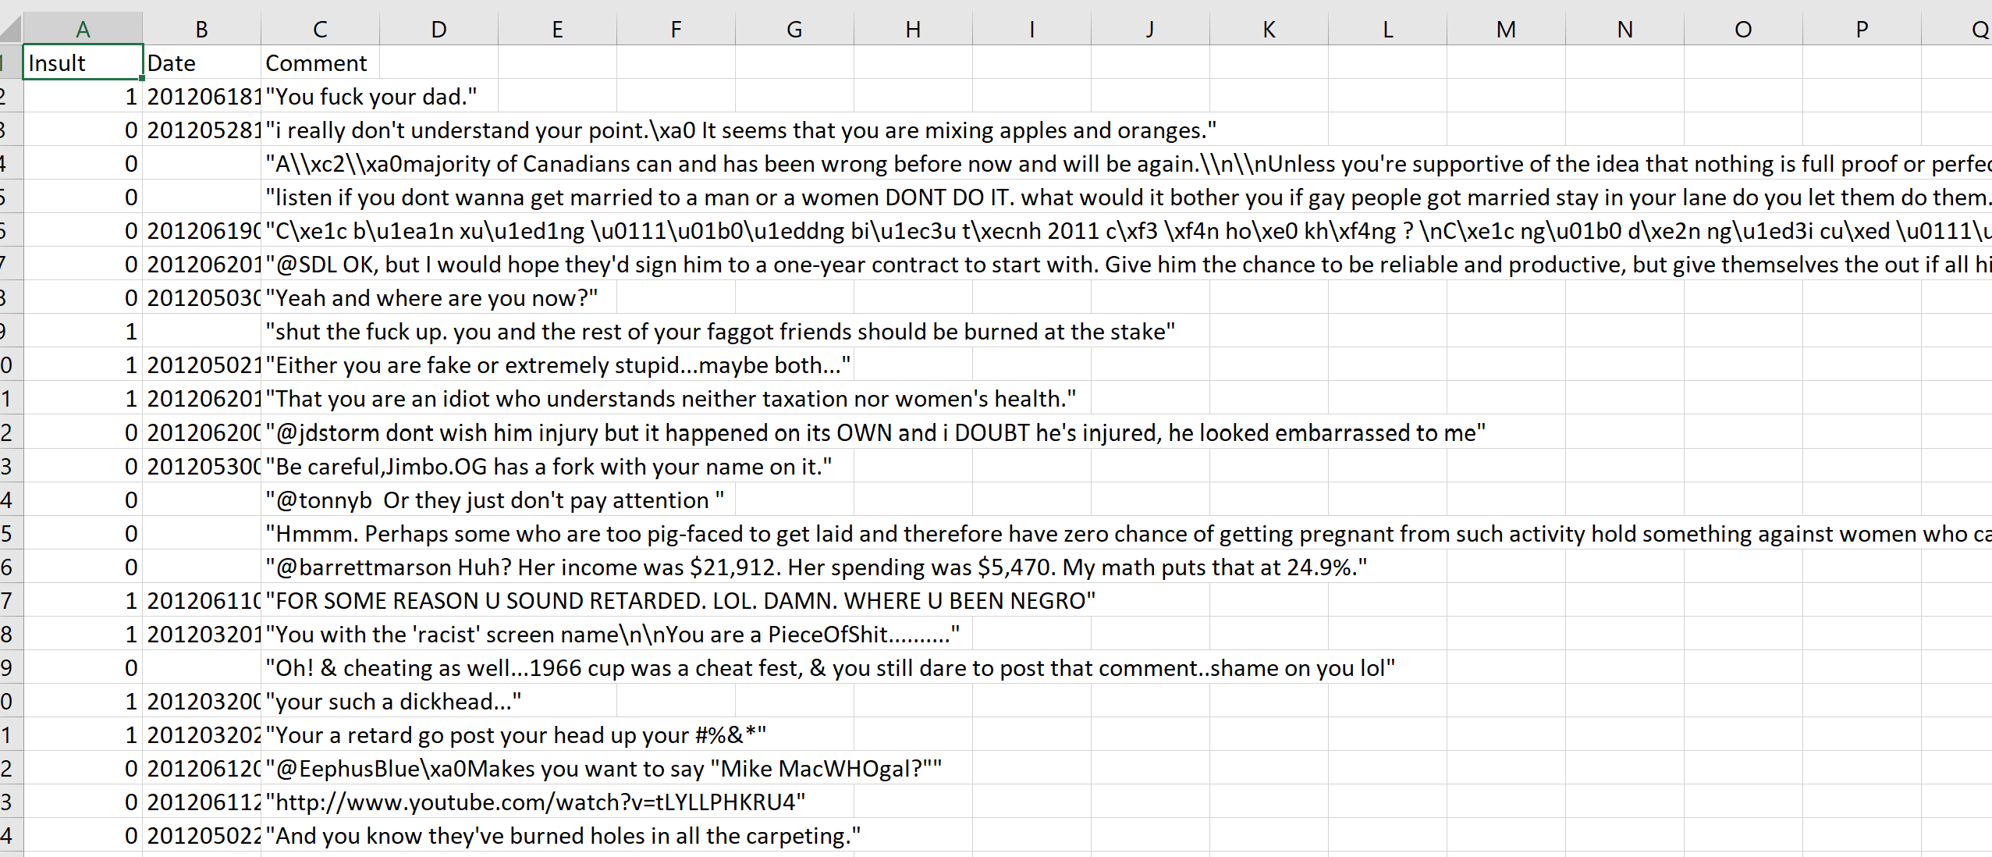
Fig. 1. A snippet of the training data set

The testing data set contains an additional column called ‘Usage’, however it is not relevant to our project at the moment.
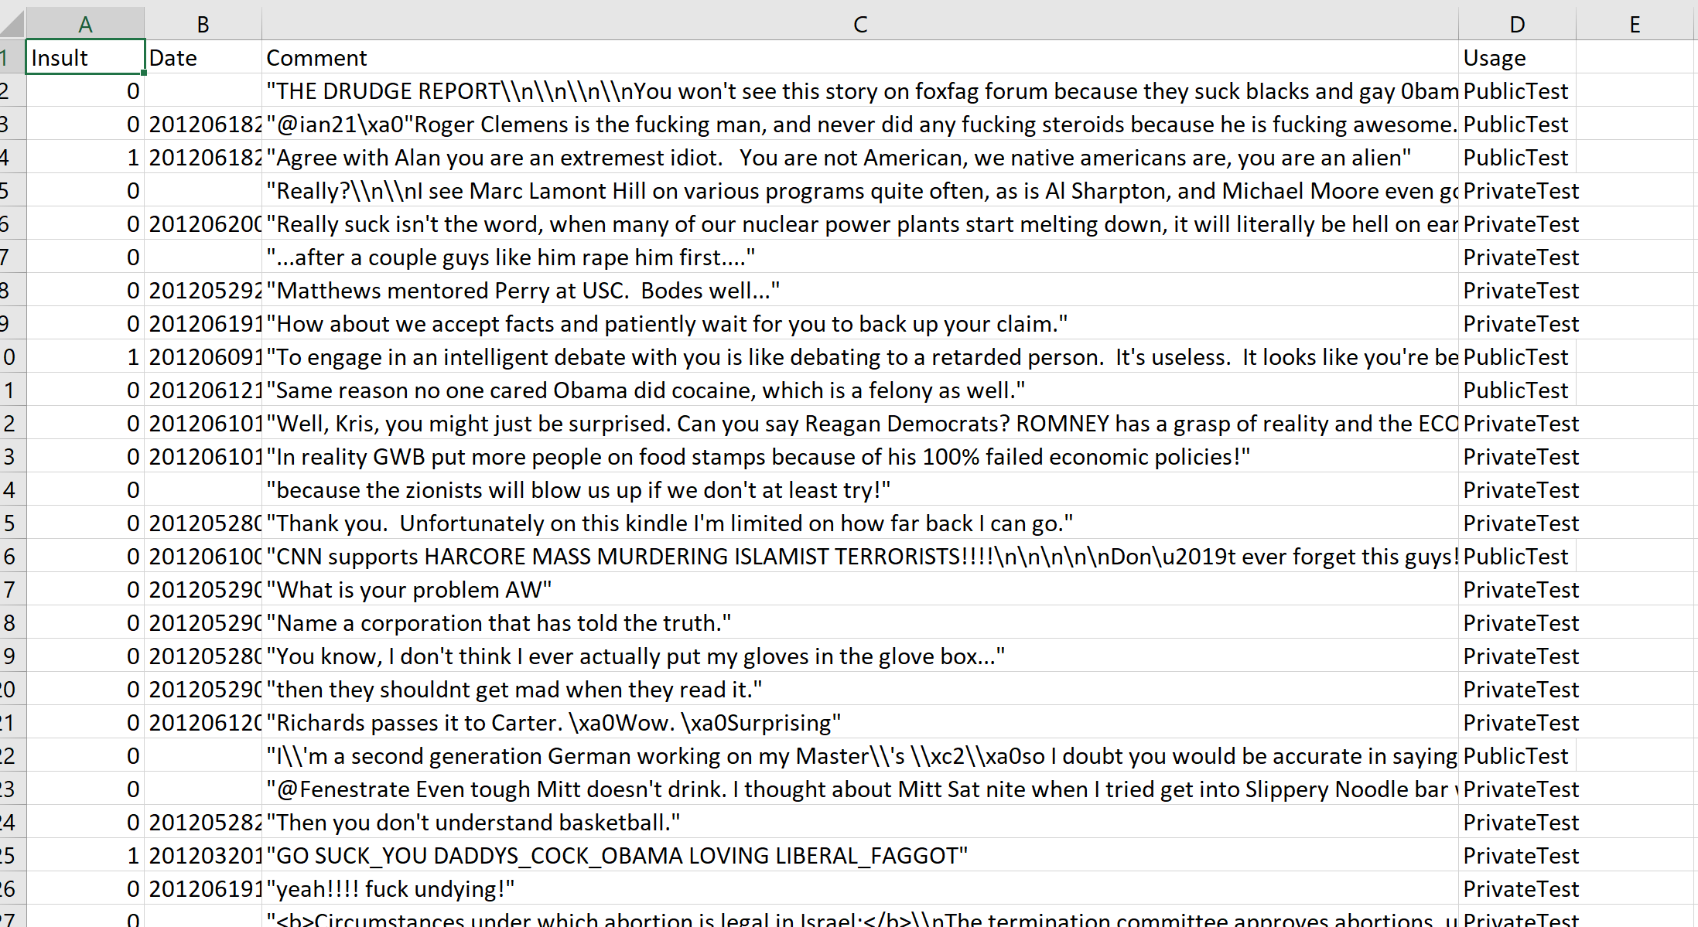
Fig. 2. A snippet of the testing data set
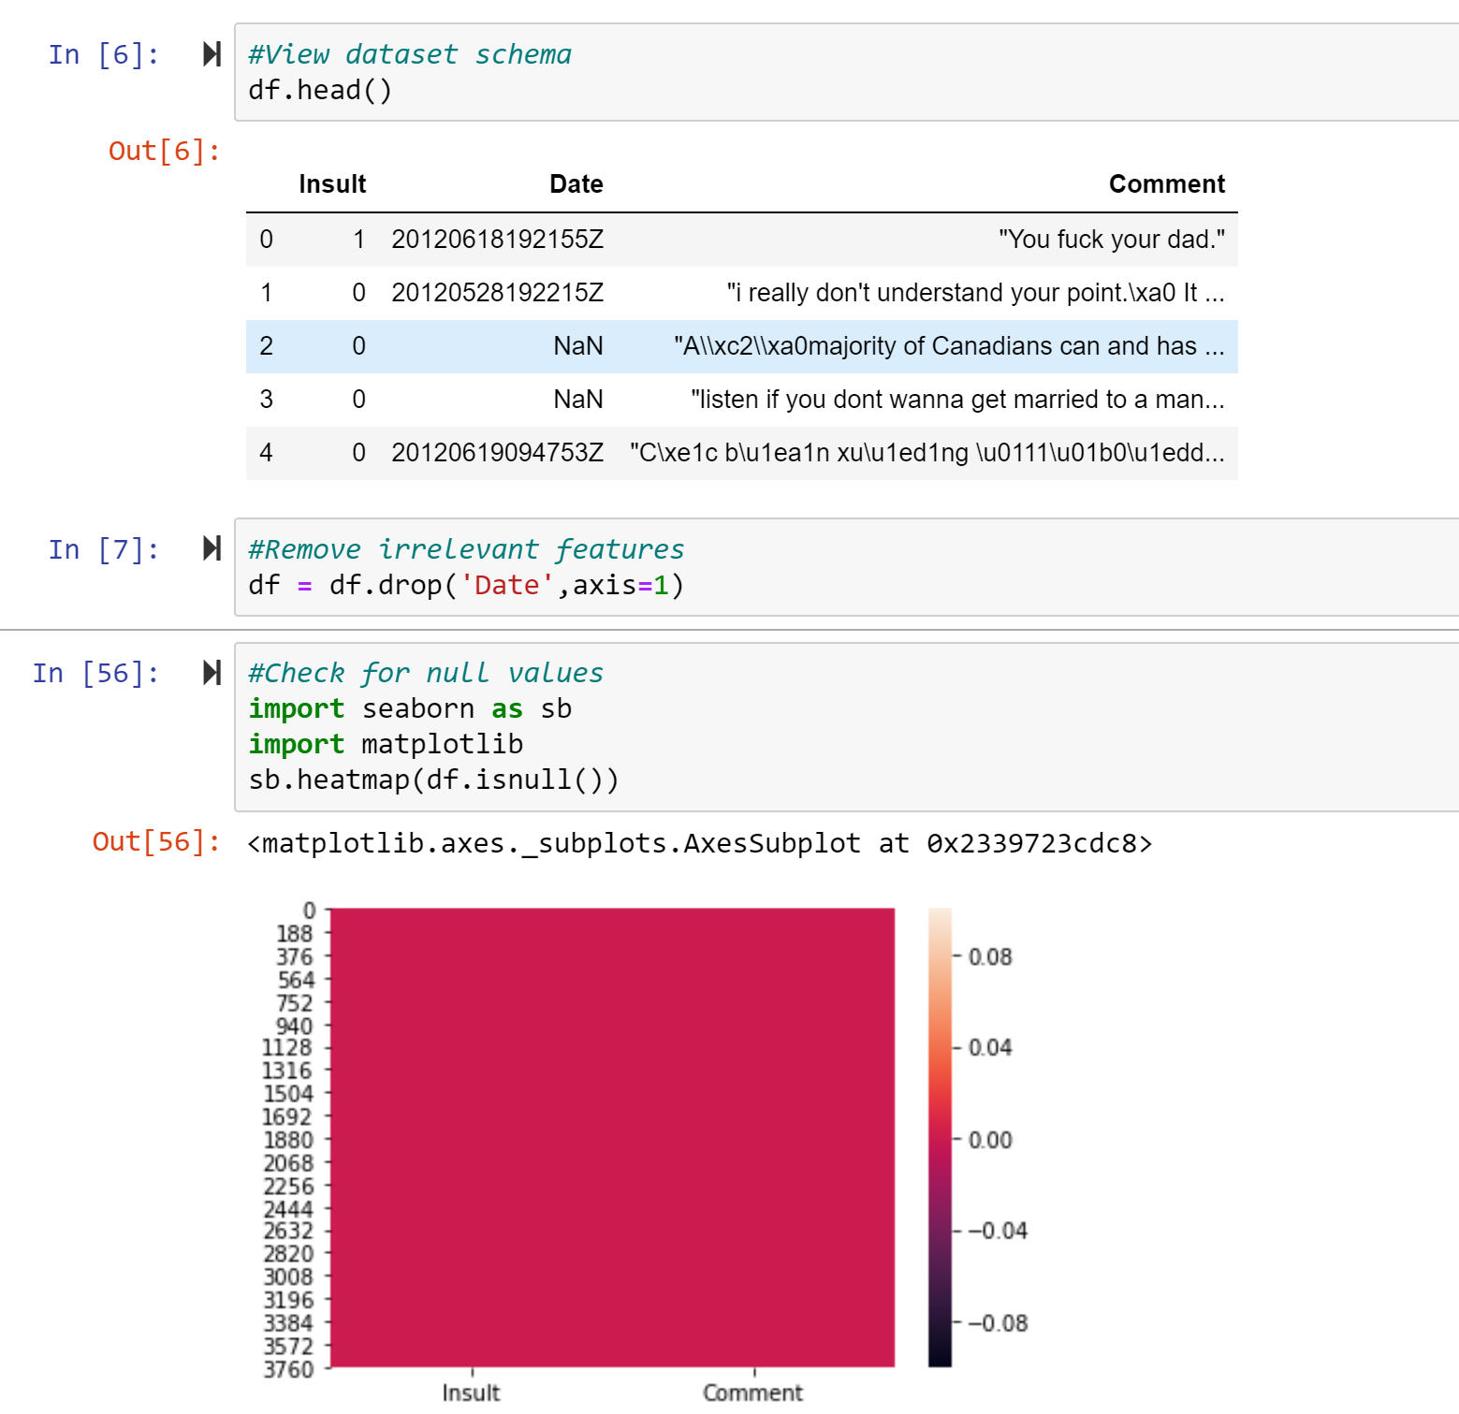
Fig. 3. Removal of irrelevant attributes from the training data set and check for duplicates, the same is also done for the testing data set.

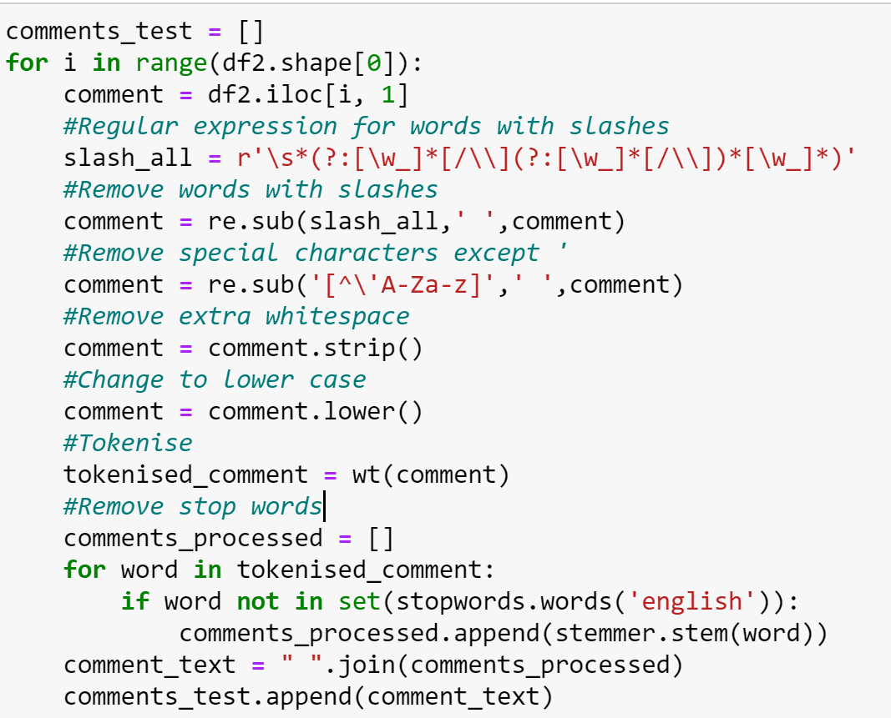
Fig. 4. The word manipulation code
Then, the feature matrix is created, and the training and testing data sets are transformed.

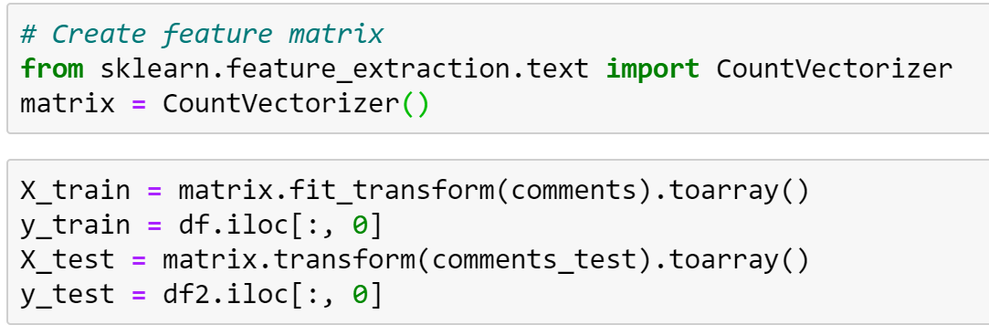
Fig. 5. The set-up

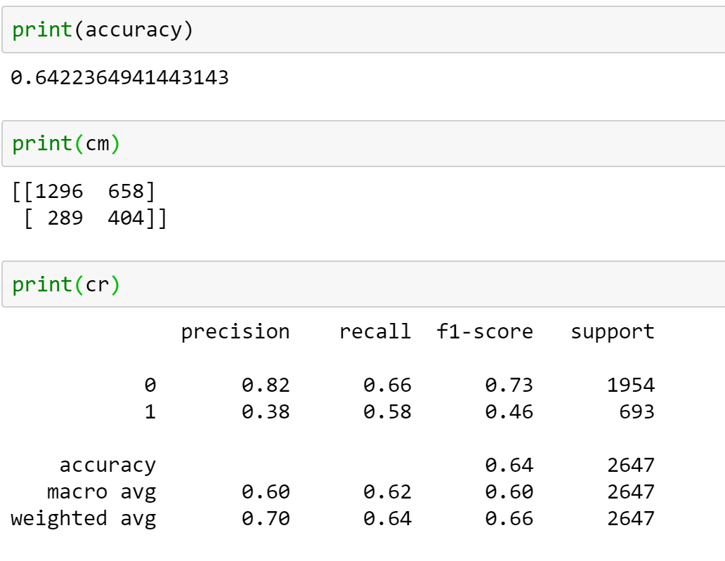
Fig. 6. The accuracy, confusion matrix and classification report for the Naïve Bayes baseline

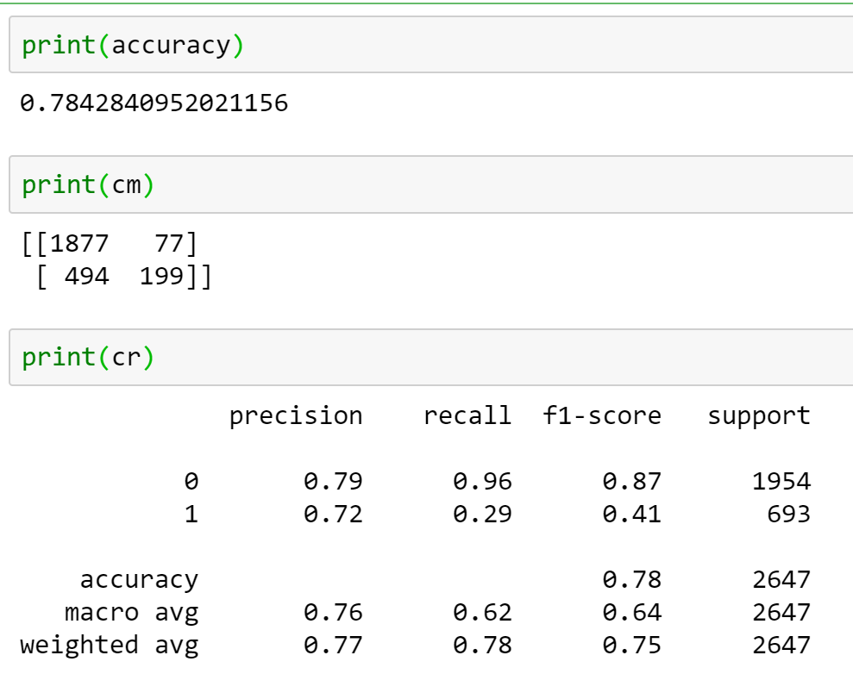
Fig. 7. The accuracy, confusion matrix and classification report for the Decision Tree baseline.
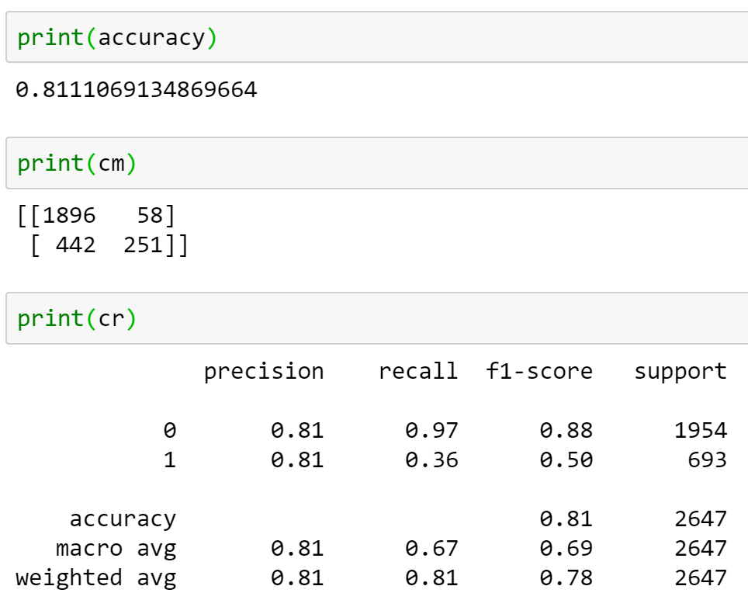
Fig. 8. The accuracy, confusion matrix and classification report for the Support Vector baseline.

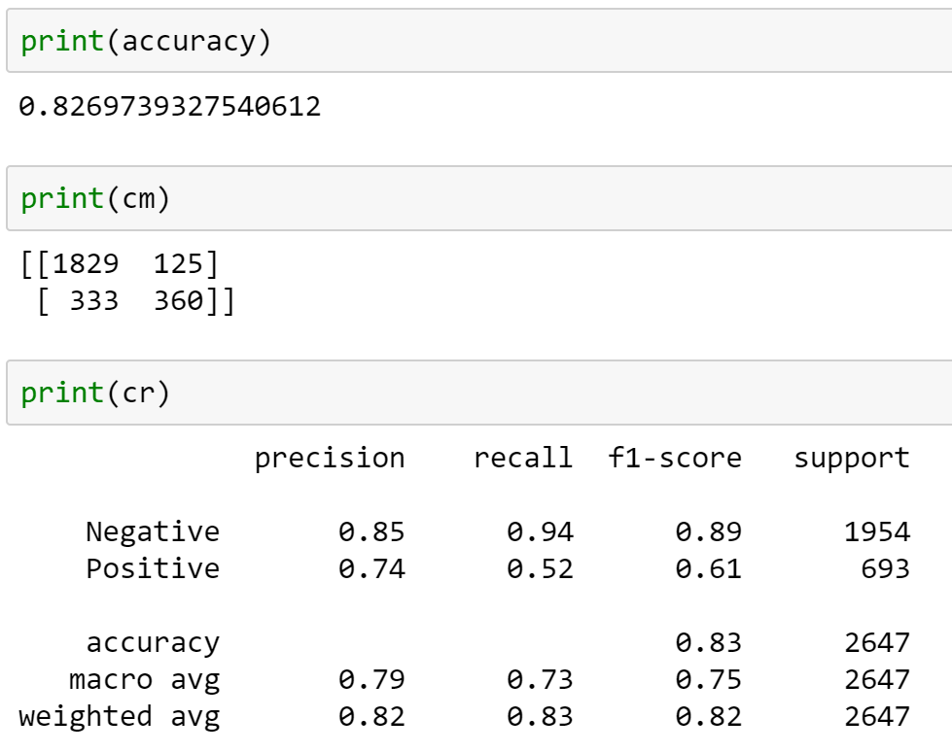
Fig. 9. The accuracy, confusion matrix and classification report for the Logistic Regression baseline.

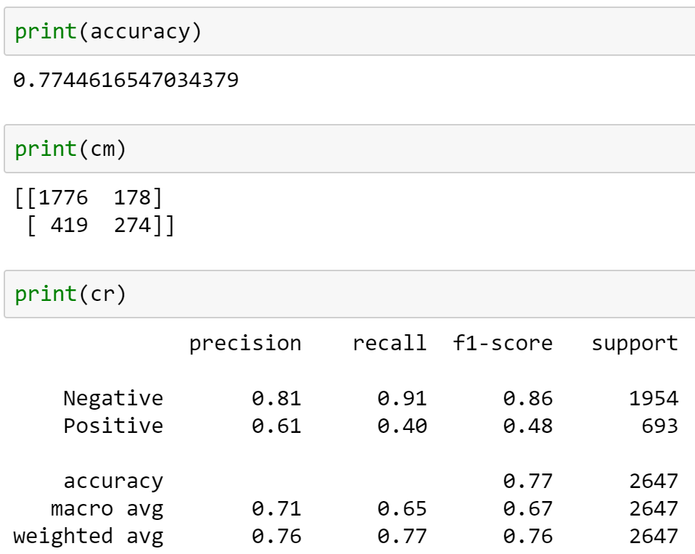
Fig. 10. The accuracy, confusion matrix and classification report for the KNN baseline.

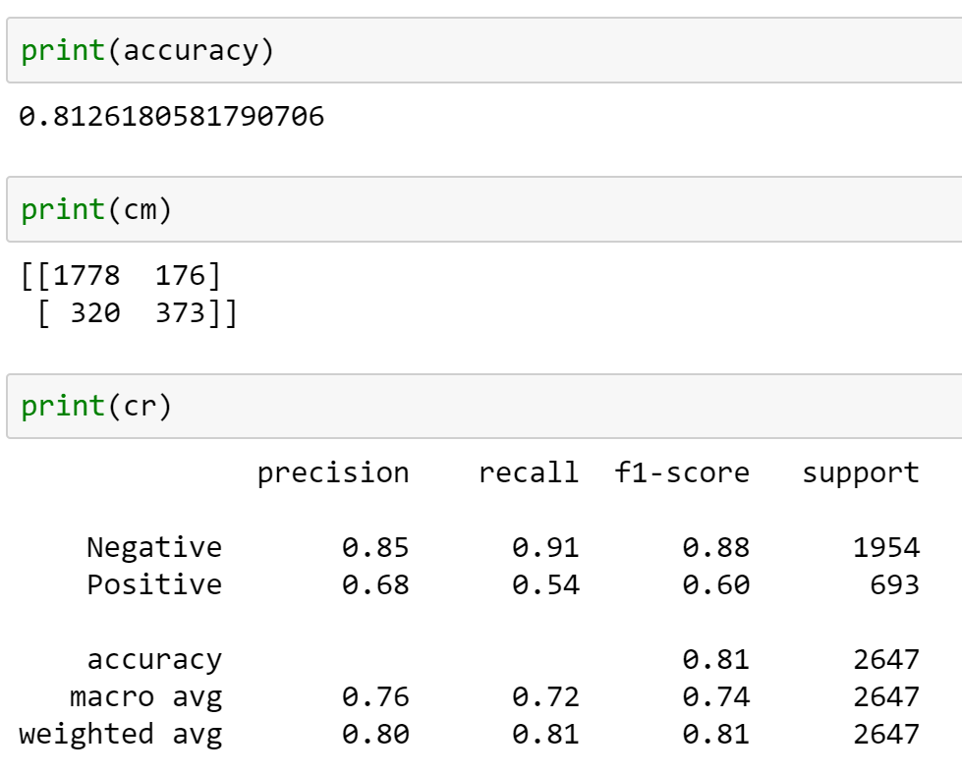
Fig. 11. The accuracy, confusion matrix and classification report for the Random Forest baseline.

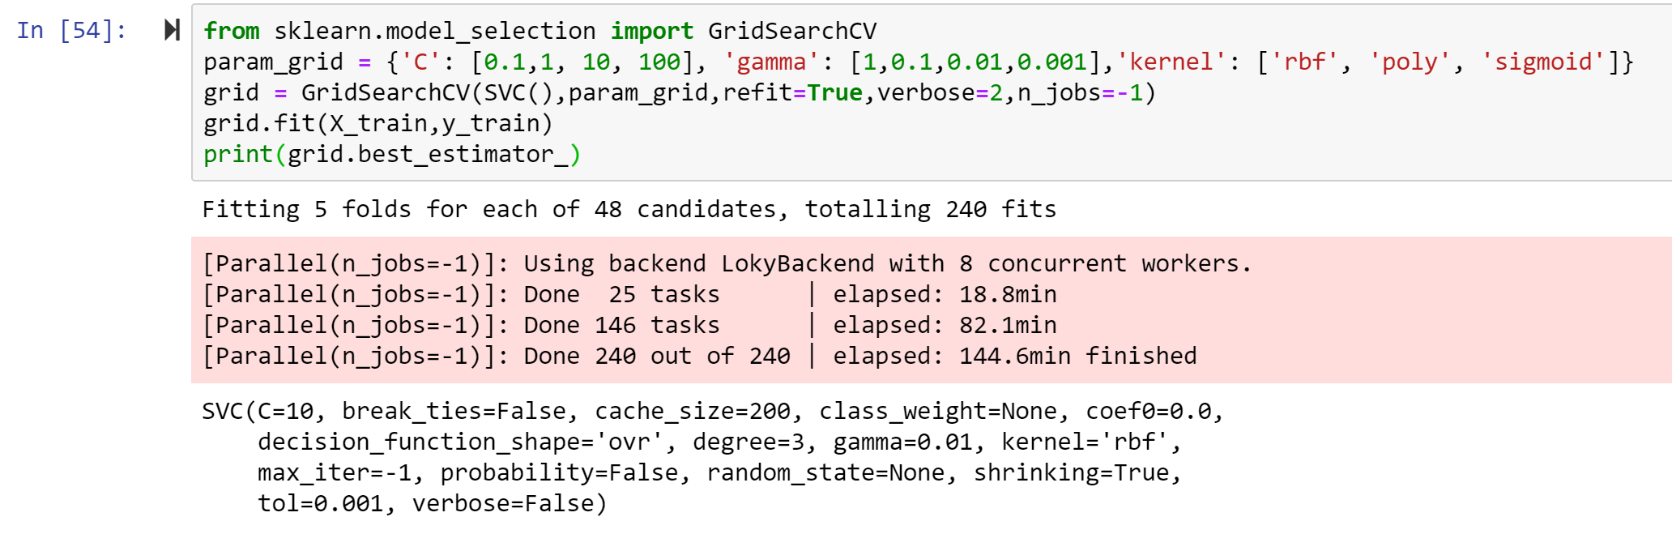
Fig. 12. GridSearch with SVC

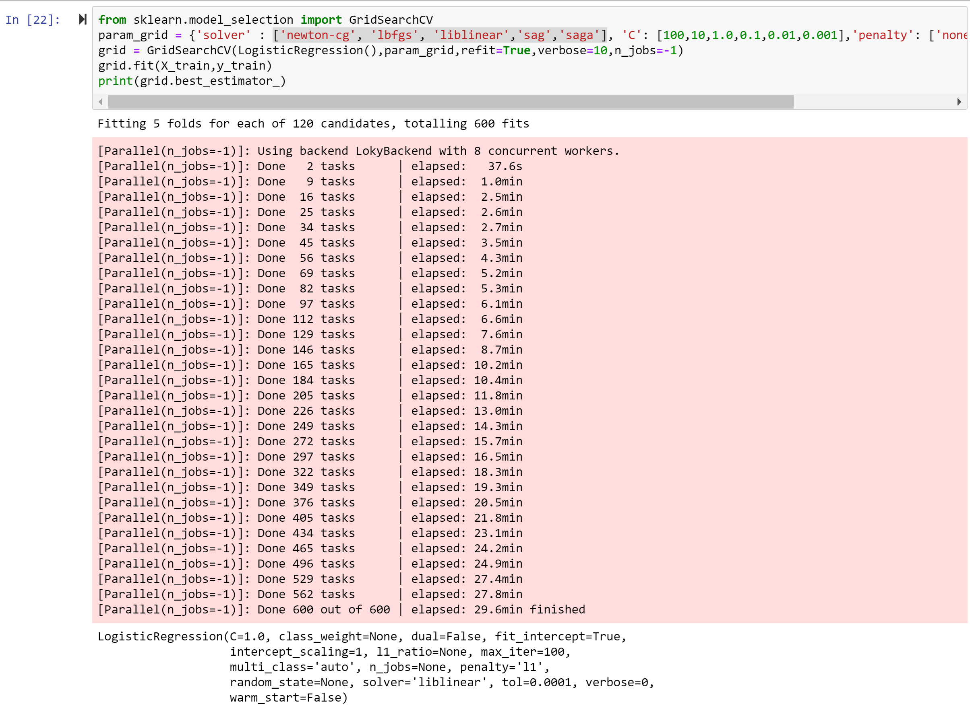
Fig. 13. GridSearch with Logistic Regression

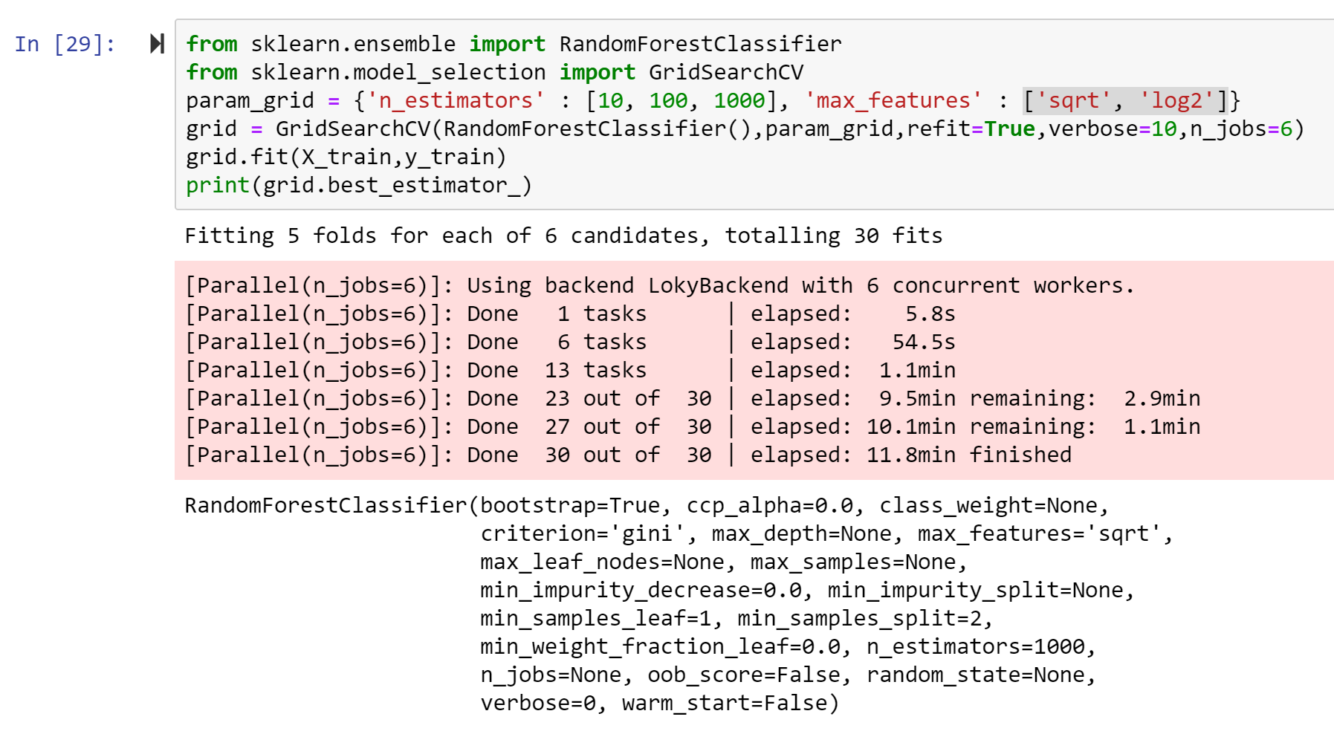
Fig. 14. GridSearch with Random Forest

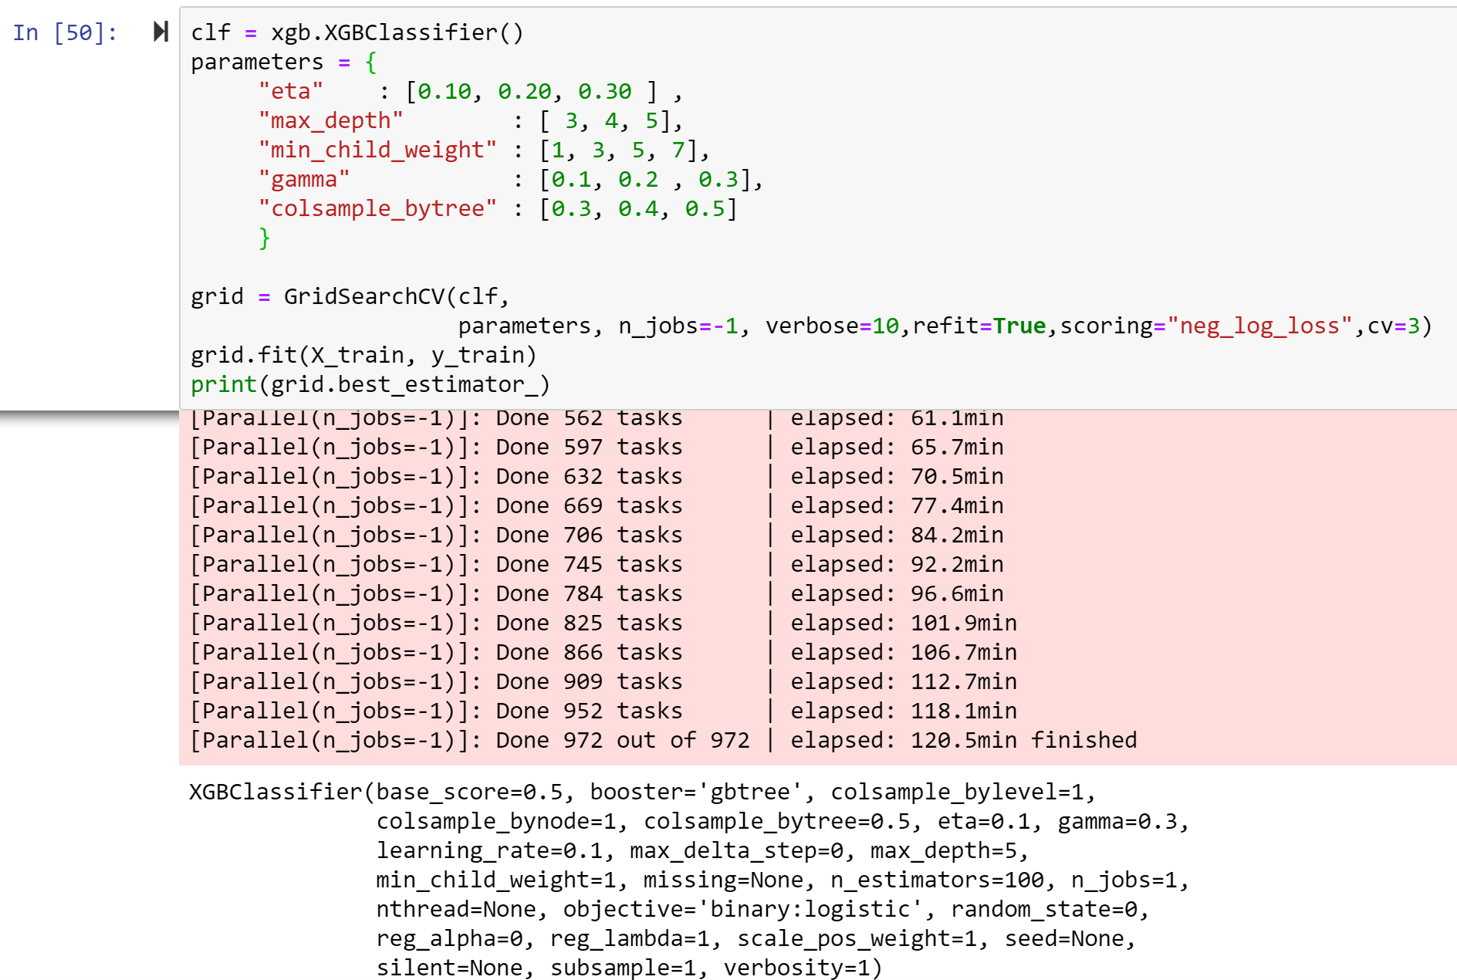

Fig. 15. GridSearch with XGBoost

